Experiment 5

Aim: - To create a date and time server using TCP/IP protocol.

Steps for server: -

1. We import socket module which helps in establishing the client/server communication. Import Time package.
2. Make the connections between client and server just as done in the simple TCP/IP client-server program.
3. Print the connection establishment between client and server and print the port address of the client.
4. Get the current time using time function in the time package and send it to the client converting it into ascii by encoding.
5. Close the server.

Steps for Client: -

1. We import socket module which helps in establishing the client/server communication. Import Time package.
2. Do the same steps we do on the client side as we do in simple TCP/IP program.
3. Use recv function to receive the time from the server.
4. Print the time received and close the connection.

Code for server :-

**import** socket  
**import** time  
  
  
serversocket = socket.socket(socket.AF_INET, socket.SOCK_STREAM)  
  
  
host = socket.gethostname()  
  
port = 9999  
  
  
serversocket.bind((host, port))  
  
  
serversocket.listen(5)  
print(**"Listening . . ."**)  
  
**while True**:  
  
 clientsocket,addr = serversocket.accept()  
  
 print(**"Got a connection from %s"** % str(addr))  
 currentTime = time.ctime(time.time()) + **"\r\n"** clientsocket.send(currentTime.encode(**'ascii'**))  
 clientsocket.close()

Code for Client :-

**import** socket  
  
  
s = socket.socket(socket.AF_INET, socket.SOCK_STREAM)  
  
  
host = socket.gethostname()  
  
port = 9999  
  
  
s.connect((host, port))  
  
  
tm = s.recv(1024)  
  
s.close()  
  
print(**"The time got from the server is %s"** % tm.decode(**'ascii'**))

Console Screenshots : -

1. 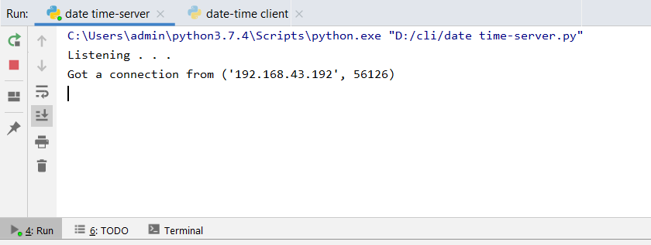Server Console : -
2. 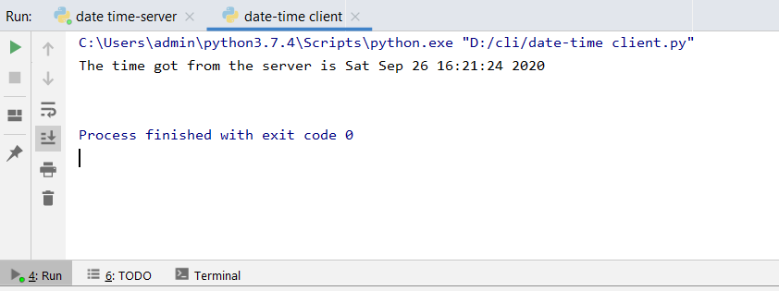Client Console : -

Result : - Date – Time server was successfully established in TCP/IP protocol.